Database Schema for marketplace
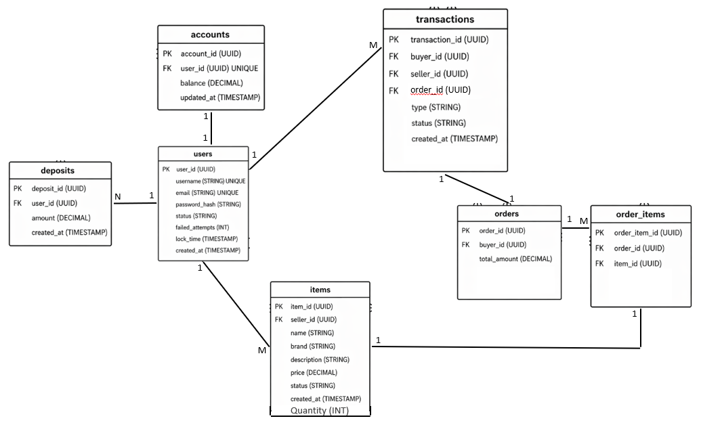

SQL code for database
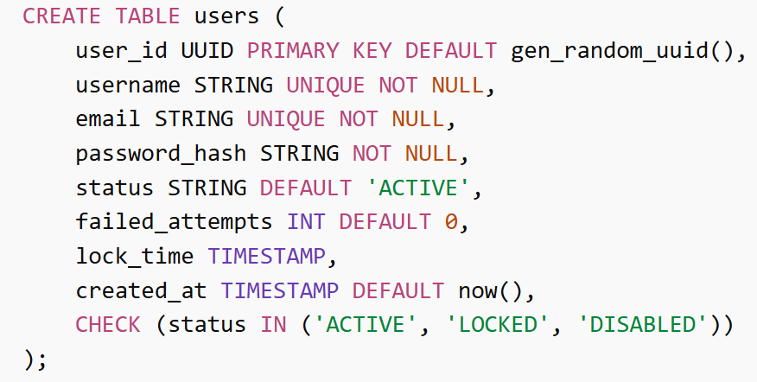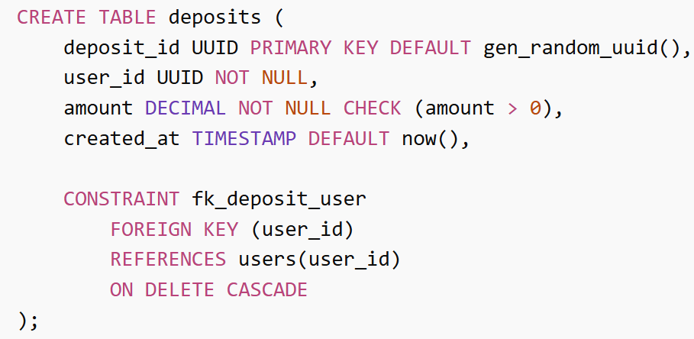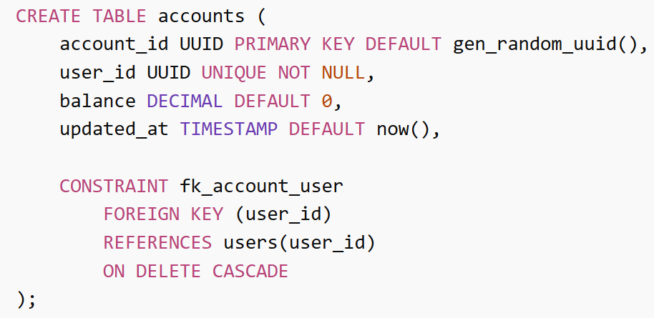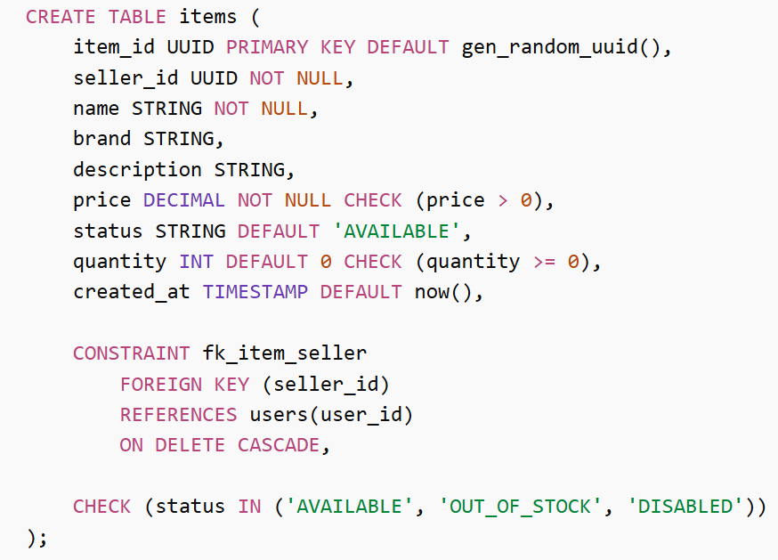

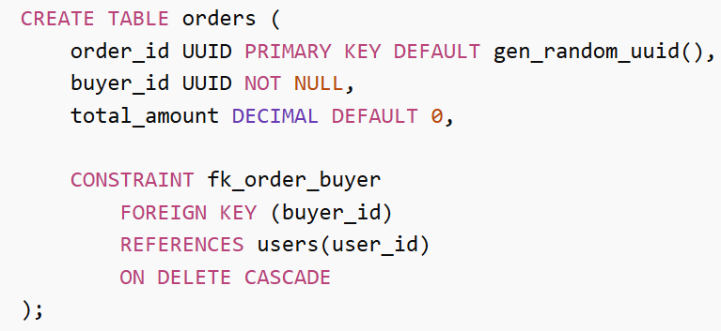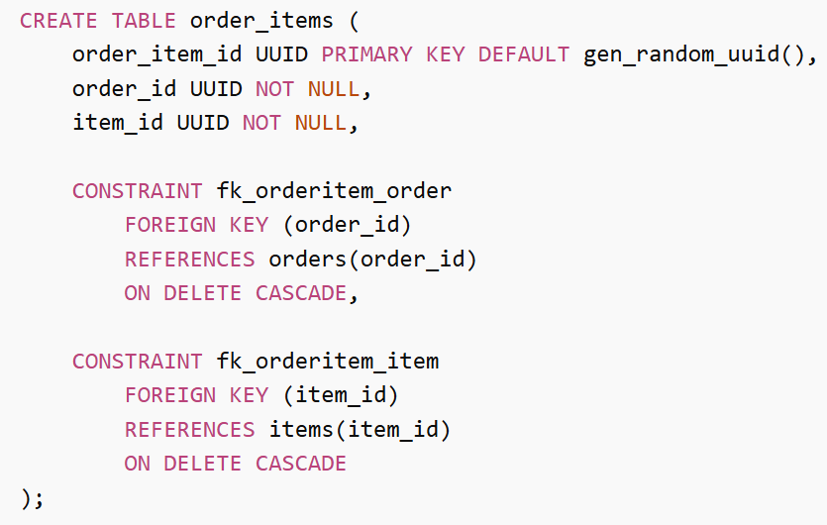
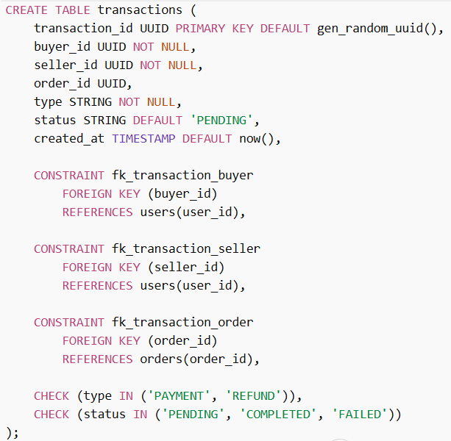
Benefits of using of cockroach DB
What is Cockroach DB?
- A distributed SQL database
- Designed for cloud applications
- Works like traditional SQL (PostgreSQL-style) but scales horizontally
Key Benefits
1. Horizontal Scalability
- Easily scale by adding more nodes
- No need to upgrade a single powerful server
- Handles large-scale systems smoothly
2. High Availability
- Data is automatically replicated across multiple nodes
- If one node fails, system keeps running
- Built-in fault tolerance
3. Distributed Architecture
- Data is spread across different machines/regions
- Enables global applications with low latency
4. Fault Tolerance & Self-Healing
- Automatically recovers from failures
- Rebalances data without manual intervention
5. SQL Support (Easy to Learn)
- Uses familiar SQL (similar to PostgreSQL)
- Easy for developers to adopt
6. Geo-Distribution
- Store data closer to users worldwide
- Improves performance and user experience
Partitioning Diagram
- Each table may be split into many ranges of rows each of 64MB or less according to traffic load
- Each range is replicated in the 3 nodes
- Automatically number of ranges (Chunks) are dynamically managed by cockroach DB itself according to traffic load or failed Nodes
- Horizontal partitioning
- Shard key is the primary key of each table so that avoid hot nodes to balance the traffic
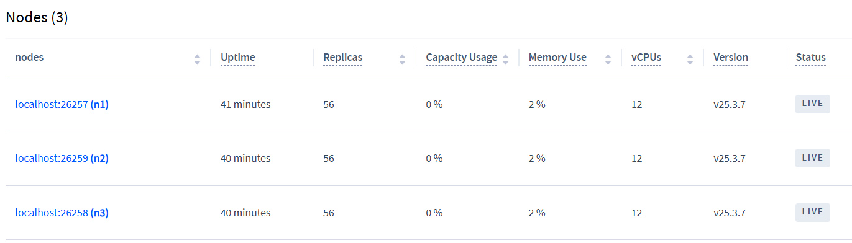

Database system architecture
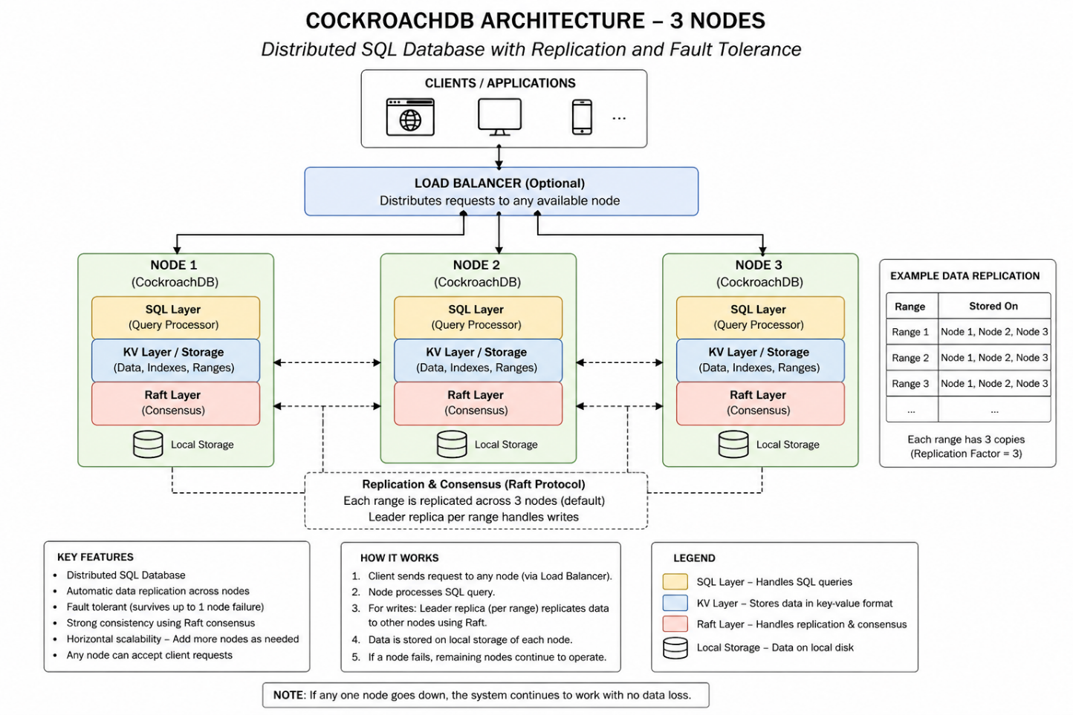
- KV is shortcut for key value indices storage for fast search
- Raft layer manages the replications between nodes in which the two nodes must agree for the update or insertion for successful query

